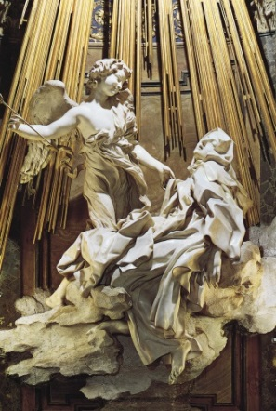 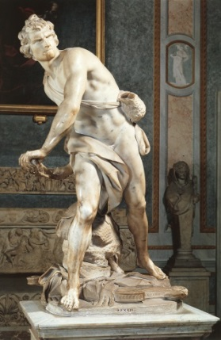 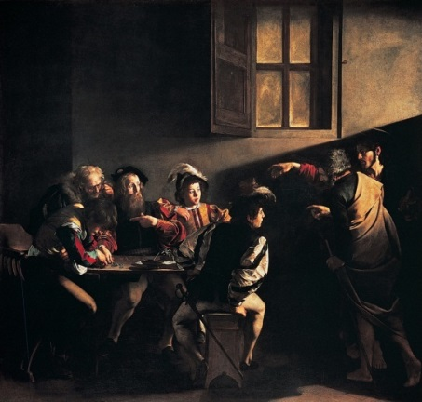 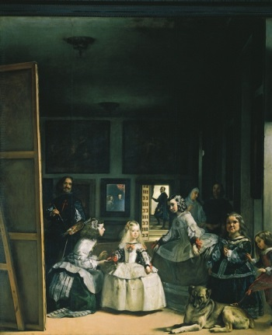

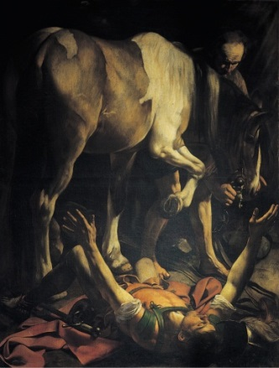 BAROQUE IMAGES 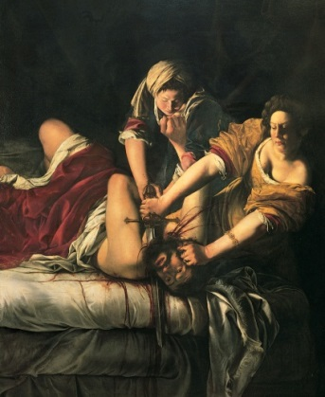 [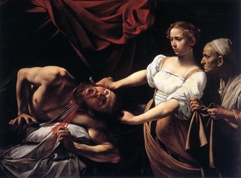](http://www.mchsapah.com/uploads/1/0/0/8/10083965/7064756_orig.jpg)

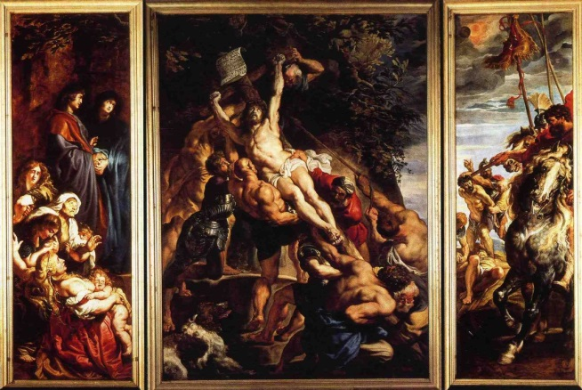 [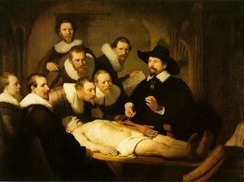](http://www.mchsapah.com/uploads/1/0/0/8/10083965/1829666_orig.jpg) [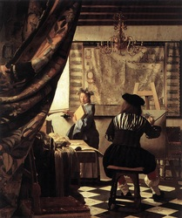](http://www.mchsapah.com/uploads/1/0/0/8/10083965/2983307_orig.jpg)

[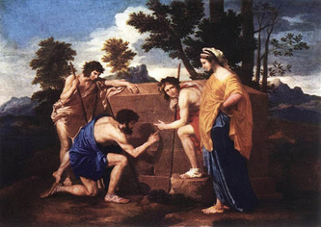](http://www.mchsapah.com/uploads/1/0/0/8/10083965/2202079_orig.jpg) [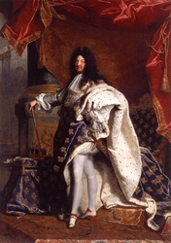](http://www.mchsapah.com/uploads/1/0/0/8/10083965/7598454_orig.jpg) [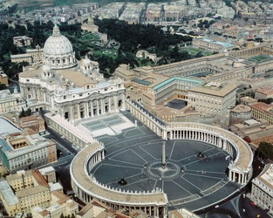](http://www.mchsapah.com/uploads/1/0/0/8/10083965/4182211_orig.jpg)

[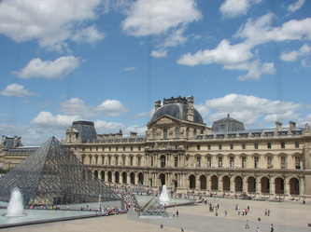](http://www.mchsapah.com/uploads/1/0/0/8/10083965/3156576_orig.jpg) [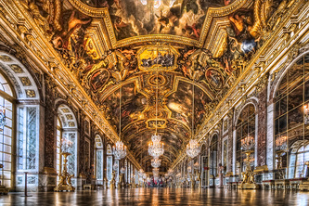](http://www.mchsapah.com/uploads/1/0/0/8/10083965/6623951_orig.jpg) 