Ch 29 Images – Rococo – Neoclassical

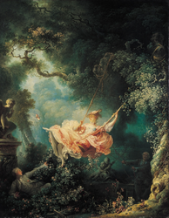 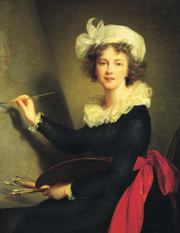 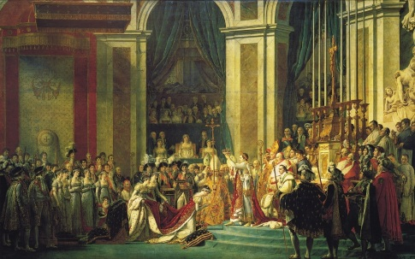

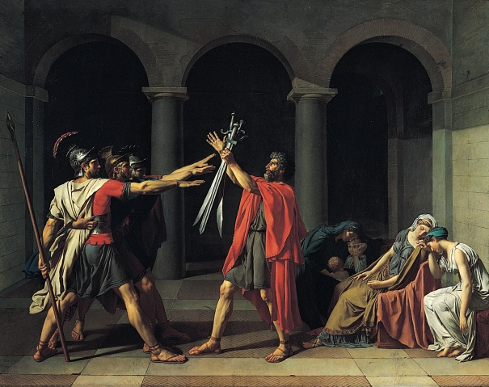 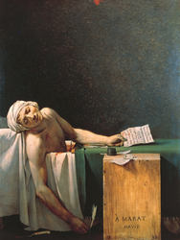 [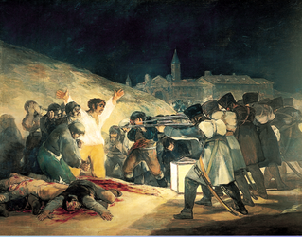](http://www.mchsapah.com/uploads/1/0/0/8/10083965/8188912_orig.png)

[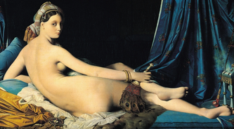](http://www.mchsapah.com/uploads/1/0/0/8/10083965/7013703_orig.png) [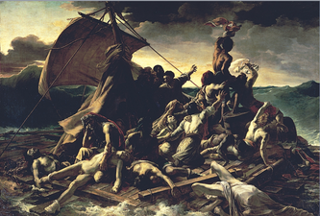](http://www.mchsapah.com/uploads/1/0/0/8/10083965/7269668_orig.png)

[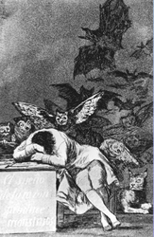](http://www.mchsapah.com/uploads/1/0/0/8/10083965/277826_orig.png) [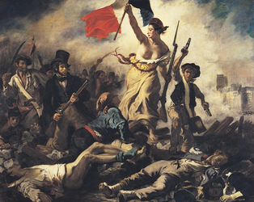](http://www.mchsapah.com/uploads/1/0/0/8/10083965/969680_orig.png) [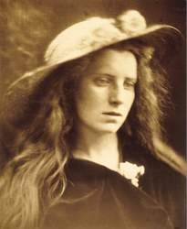](http://www.mchsapah.com/uploads/1/0/0/8/10083965/2948586_orig.png)

[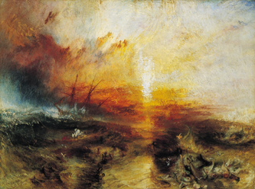](http://www.mchsapah.com/uploads/1/0/0/8/10083965/5969721_orig.png) [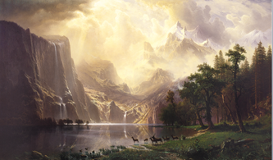](http://www.mchsapah.com/uploads/1/0/0/8/10083965/4619573_orig.png)

[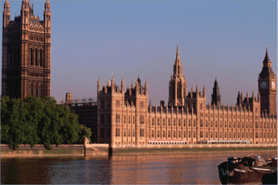](http://www.mchsapah.com/uploads/1/0/0/8/10083965/5899434_orig.png) [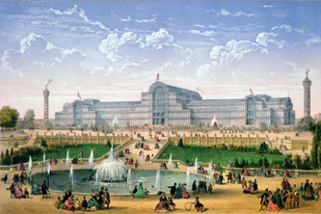](http://www.mchsapah.com/uploads/1/0/0/8/10083965/8769102_orig.png)

[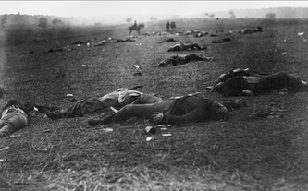](http://www.mchsapah.com/uploads/1/0/0/8/10083965/7829070_orig.png) [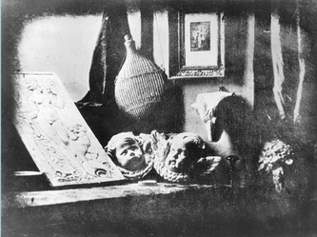](http://www.mchsapah.com/uploads/1/0/0/8/10083965/4108835_orig.png)