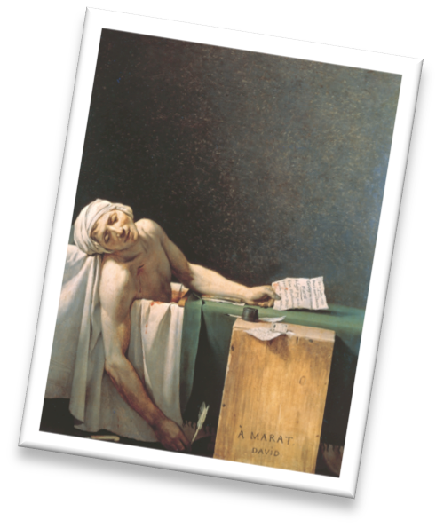Mira Costa High School Ms. Park 2013-2014

Age of Enlightenment
The Enlightenment was a new way of thinking and people moved away from extreme religious thinking and could learn to analyze the world and the environment. Critical thinking was based on empirical evidence. The American Revolution and the French Revolution were the result of no longer

History: 1715 Death of Louis XIV brought a resurgence of aristocratic life.
1789 French Revolution →→ brings about an interest in the Greek ideal of Liberty and democracy. 1804 Napoleon crowns himself and sees himself as a new "Caesar"
~1770 Neoclassicism takes architectural hold in the U.S. with Thomas Jefferson.
Late 1800s: New ways of thinking about the new world. →→Start of the Industrial Revolution→→Cast Iron

Philosophy: Voltaire (1694-1778) = Science/Technological Improvement
Rousseau (1712-1778) = Nature alone must be society's guide
Romanticism influenced by spirit of individuality- freedom of expression→→ Enjoying the sublime in nature Patronage: Town houses became centers for the Rococo style.

Gardner’s Art Through the Ages, 12th ed. Chapter 28- Pages 797-850

Timeline
Artworks

Need to know date: 1730: Rococo (French)
1800: Neoclassical (French and American)
1830: Romanticism (England, France, Spain, America)

1712-1783 Rousseau

1763-1783 American Revolution

1776 Declaration of Independence 1789-1795 French Revolution
1804 Napoleon crowned Emperor French Revolution of 1830
1837 Daguerreotype presented

1818-1883 Karl Marx

Artist Artwork Date Key Idea

Rococo

Fragonard The Swing 1766 Rococo Intrigue

Taste for the Natural
Lebrun Self-Portrait 1790 Nature

Neoclassic
David The Death of Marat 1793 Revolution
David The Coronation of Napoleon 1805 Neoclassic Royalty Latrobe and L’Enfant Capitol of Washington 1803 Neoclassic

Romantic

Ingres Grande Odalisque 1814 Romantic
Goya The Sleep of Reason 1798 Dark Romanticism
Goya The Third of May 1814 Spanish Politics
Gericault Raft of Medusa 1818 Romantic colorist
Delacroix Liberty Leading the People 1830 Romantic

Turner The Slave Ship 1840 English colorist
Bierstadt Among the Sierra Nevada Mts. 1868 Romanticized

Barry Houses of Parliament 1835 Revivalist (Gothic)
Paxton Crystal Palace 1850 Iron and glass

Photography

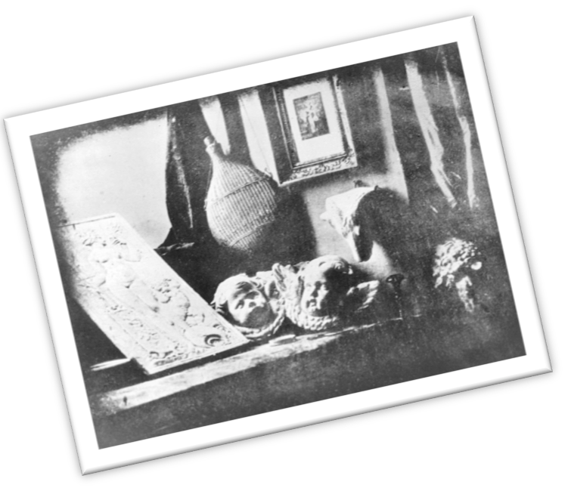
Daguerre
Cameron O’Sullivan
Still Life in Studio
Ophelia, Study no. 2 A Harvest of Death
1837 Daguerreotypes
1867 Female artists
1863 Documenting war
Rococo
Vocabulary
Fête Galante “Poussanists” (classicists)
Enlightenment
cast-iron
“Rubenistes” (colorists)
Intrigue painting
Romanticism
Academy
Calotype
Camera obscura
Daguerreotype
http://www.mchsapah.com/28-art-of-the-age-of-enlightenment.html

