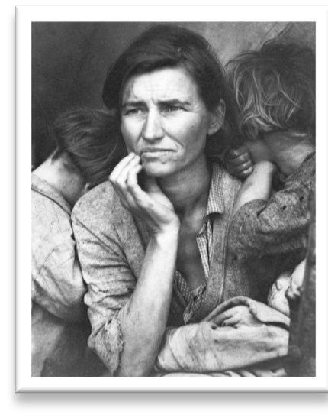
Modernism
The first half of the 20th c. was a period of significant upheaval worldwide. The globe saw major industrial powers expand their colonial empires, it fought 2 global wars, Communism, Fascism, and Nazism was on the rise, and suffered the Great Depression. This was also a time of radical change with the arts with great risks.

History: Imperialist Expansion: Britain, France, Germany, Belgium, Italy, Spain, Portugal →→ Africa footholds
Britain →→ India Dutch →→ Indochina
Russia →→ Central Asia and Siberia
Japan as its own rising formidable power in the Pacific

1917 The US entered World War I
Context
1930s Great Depression: Huge economic difficulties in the US and other Western countries 1920s-1930s Rise of Totalitarianism: Mussolini in Italy, Stalin in the Soviet Union, Hitler in Germany
1941 The US entered World War II with the bombing of Pearl Harbor by the Japanese 1945 WWII ends: The Allied forces defeated Germany, US dropped atomic bombs in Hiroshima and Nagasaki

Movements:

Europe (1900-1920) (1920-1945) Utopian Ideals
Fauvism and Expressionism Russia: Suprematism and Constructivism
French Leaders: Matisse, Derain, Kandinsky Holland: De Stijl →→Mondrian
German varieties: Die Brücke and Der Blaue Reiter Germany: Bauhaus and intensities of war Abstraction Leaders: Picasso and Braque
Dada Leader: Duchamp
America (1900-1930) (1940-1945) Organic Styles
Armory Show of 1913 →→ NY as world’s Art Center Architecture: F.L. Wright
→→ O’Keefe, Stieglitz, Man Ray Depression and Fascist years, Regionalism

Timeline
Artworks

***Clearly these artworks are not arranged in chronological order. Please know these works by movement.
 |  | Socialist artist | Kollwitz | *Woman with Dead Child | 1903 | Maternal Loss
Need to know dates: |  | Fauvism | Matisse | *Woman with the Hat | 1905 | color
1907: Fauvism |  | German Expressionism | Kirchner | *Street, Dresden | 1908 | Die Brücke
1910: Cubism |  |  | Kandinsky | *Untitled | 1910 | Der Blaue Reiter
1914: Futurism, German |  | Early Cubism | Picasso | *Le Demoiselle d’Avignon | 1907 | 1st modernists
Expressionists |  | Cubism | Braque | The Portuguese | 1911 | Analytic cubism
1916: Dada |  |  | Picasso | *Still Life with Chair-Caning | 1912 | Synthetic cubism
1920: Art Deco |  | Futurism | Boccioni | Unique Forms of Continuity in Space | 1913 | Facist Furturism
1930: Surrealism/ Bauhaus |  | Dada | Arp | Collage According to the Laws… | 1916 | collage
 |  |  | Duchamp | *Fountain (original) | 1917 | “ready made”
 |  |  | Höch | *Cut with a Kitchen Knife… | 1919 | photomontage
1903 | Wright Bros. 1st flight | Precisionism | O’Keeffe | Jack in the Pulpit No. 4 | 1930 | Expressive power
 |  | Surrealism | Dali | Persistence of Memory | 1931 | dreamscape
1905 | Die Brucke formed |  | Magritte | *The Treachery of Images | 1928 | Image vs. Reality
 |  |  | Kahlo | *The Two Fridas | 1939 | Psychological pain
1911 | Der Blaue Reiter |  | Klee | Twittering Machine | 1922 | Fantasy
 |  | De Stijl | Mondrian | *Composition in Red, Blue, and Yellow | 1930 | Dynamic tension
1919 | Bauhaus founded | Bauhaus | Albers | Homage to the Square | 1953 | Design prinicples
 |  | Art Deco | Alen | Chrysler Building | 1928 | Skyscrapers
1929 | Stock Market crashes | Natural Architecture | Wright | Kaufmann House | 1936 | Emphasizing organic
 |  | Organic Sculpture | Calder | *Untitled | 1976 | Mobiles
1936 | Start of Spanish Civil War | Post War | Picasso | *Guernica | 1937 | Political statements
 |  | Depression | Lange | *Migrant Mother | 1935 | Photojournalism

1939-1945 WWII
Regionalism Wood American Gothic 1930 Midwestern life

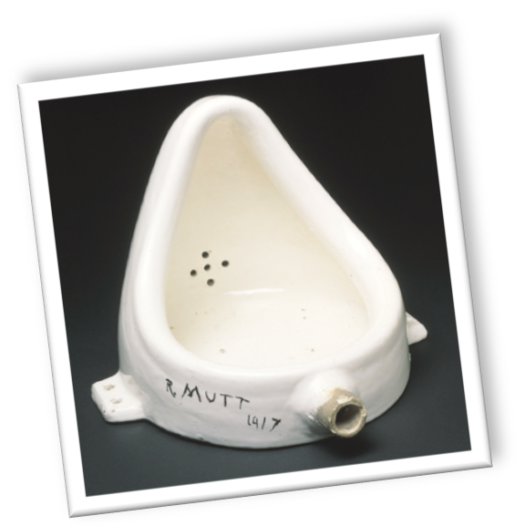
modernist
“Der Blaue Reiter”
Purism
“Neue Sachlichkeit” Constructivism DecoOrganic Style
Expressionism
Cubism
Futurist “Dada” surrealism
De Stijl
Vocabulary
Fauvism Analytic Cubism
The Armory Show 1913 Utopian Ideals Bauhaus
“Die Brücke”
Synthetic Cubism
Depression Muralists avant garde
Suprematism
International Style Art Harlem Renaissance

