AP Art History Chapter 18 Reading Notes Name ___________________________

Gothic Art and Architecture

1) Define the following:

Abbot Suger:

- Rose Window:

- Fan vault:

- Flying Buttress:

- Ogee arch:

2) What did a Gothic Cathedral Symbolize?

3) List three of the features of the new choir at St. Denis as described by Abbot Suger that are characteristic of the new Gothic style.

a.

b.

c.

4) List 3 structural of design features that characterize the Gothic vault.

a.

b.

c.

5) What are the advantages of the pointed arch over the rounded arch?

6) In what ways do the jamb figures on the Portal of Chartres differ from Romanesque figures?

7) List 3 features that retained the Romanesque style in the Laon Cathedral and 3 features that are the new Gothic style.

8) Describe the modification made in the nave elevation of Notre Dame of Paris that changed it from Early to High Gothic architecture.

9) What is the function of a flying buttress?

10) What spatial effect did the new bay structure of Chartres have?

11) How did stained glass windows change from the 12th to the 13th century?

12) Describe the different features of a stained glass window.

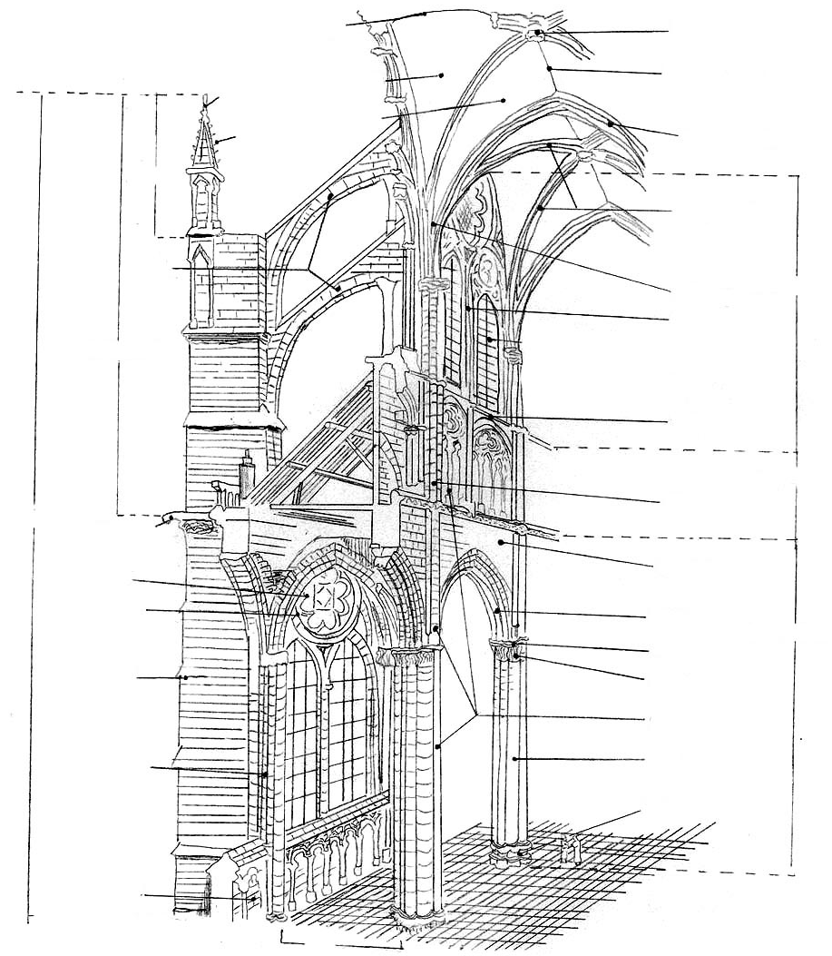
13) Label all of these parts on the above diagram:

Oculus | Vaulting web | Transverse arch | Pinnacle | Stringcourse
Respond | Spandrel | Crocket | Abacus | Arcade arch
 | Pier |  | Diagonal rib | Buttress
Gargoyle | Buttress pier | Flying buttress | Capital | Finial
Lateral web | Pier | Base | Shaft | Vaulting web

14) What is the difference between plate tracery and bar tracery?

15) What major change do you see in the façade of Reims?

16) The rayonnant style developed in the second half of the _______________________century and was

associated with the court of ______________________________.

17) Describe the rayonnant style.

18) What was the purpose of Saint Chapelle in Parish and how did its structure reflect that purpose?

19) List 5 features of Salisbury Cathedral that distinguish it from French Gothic.

a.

b.

c.

d.

e.

20) The last English Gothic style, seen at Gloucester, is called ___________________________.
It is characterized by the following features:

a.

b.

