Name: ____________________ AP Art History- Caron
Chapter 2: Comparing Stele, Free Response

Directions:
Write at least one page comparing the Victory Stele of Eannatum (pg. 36) and the Victory Stele of Naram-Sin (pg. 40) Include in your comparison an analysis of each of the images based on the following: composition, material, and technique. How do the stylistic features emphasize the main subject? In what ways did the artist portray the story of victory? Which of the two images do you think is most effective and why?
Legible hand written work or typed response will be accepted. Use this free response as a practice. Try not to spend more than 10 minutes on it.
This assignment is due on: ________________________

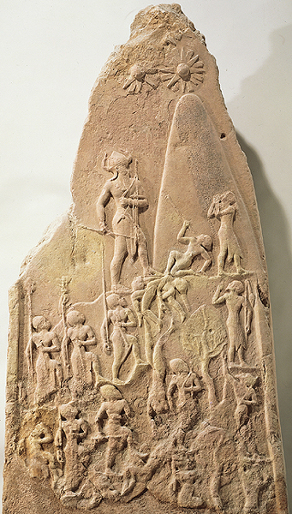
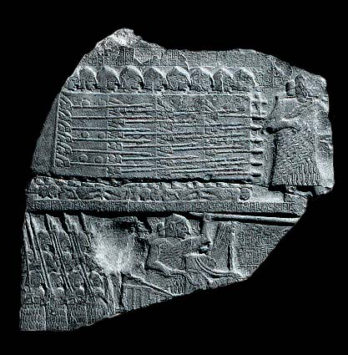
Fragment of the Victory stele of Eannatum (Stele of Vultures), from Girsu (modern Telloh), Iraq, ca. 2600-2500 BCE. Limestone, fragment 2’6” high, Louvre, Paris, France.

Victory stele of Naram-Sin, from Susa, Iran, 2254-2218 BCE. Pink sandstone, 6’7”high, Louvre, Paris, France.

