Chapter 35 Images

[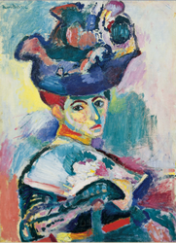](http://www.mchsapah.com/uploads/1/0/0/8/10083965/6329897_orig.png) 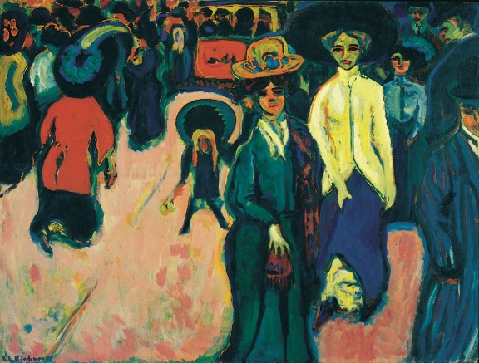 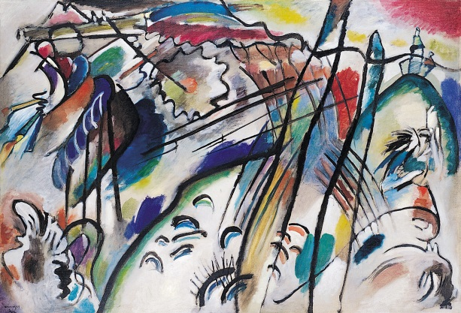

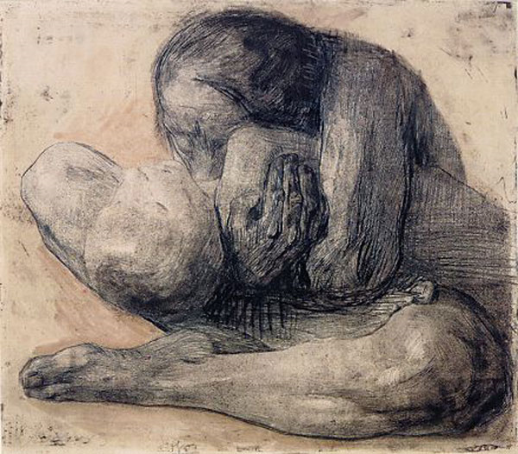 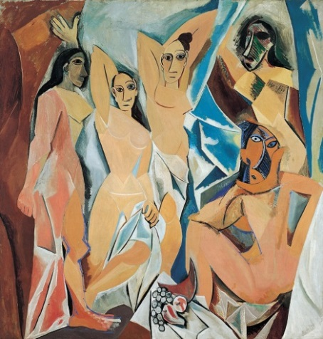 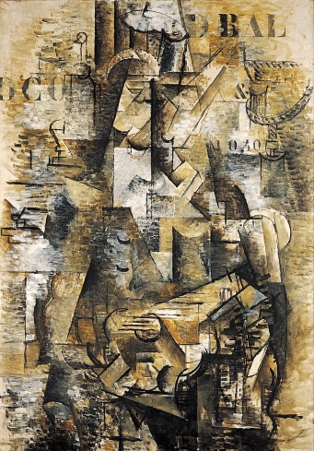 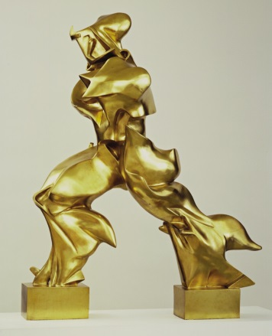

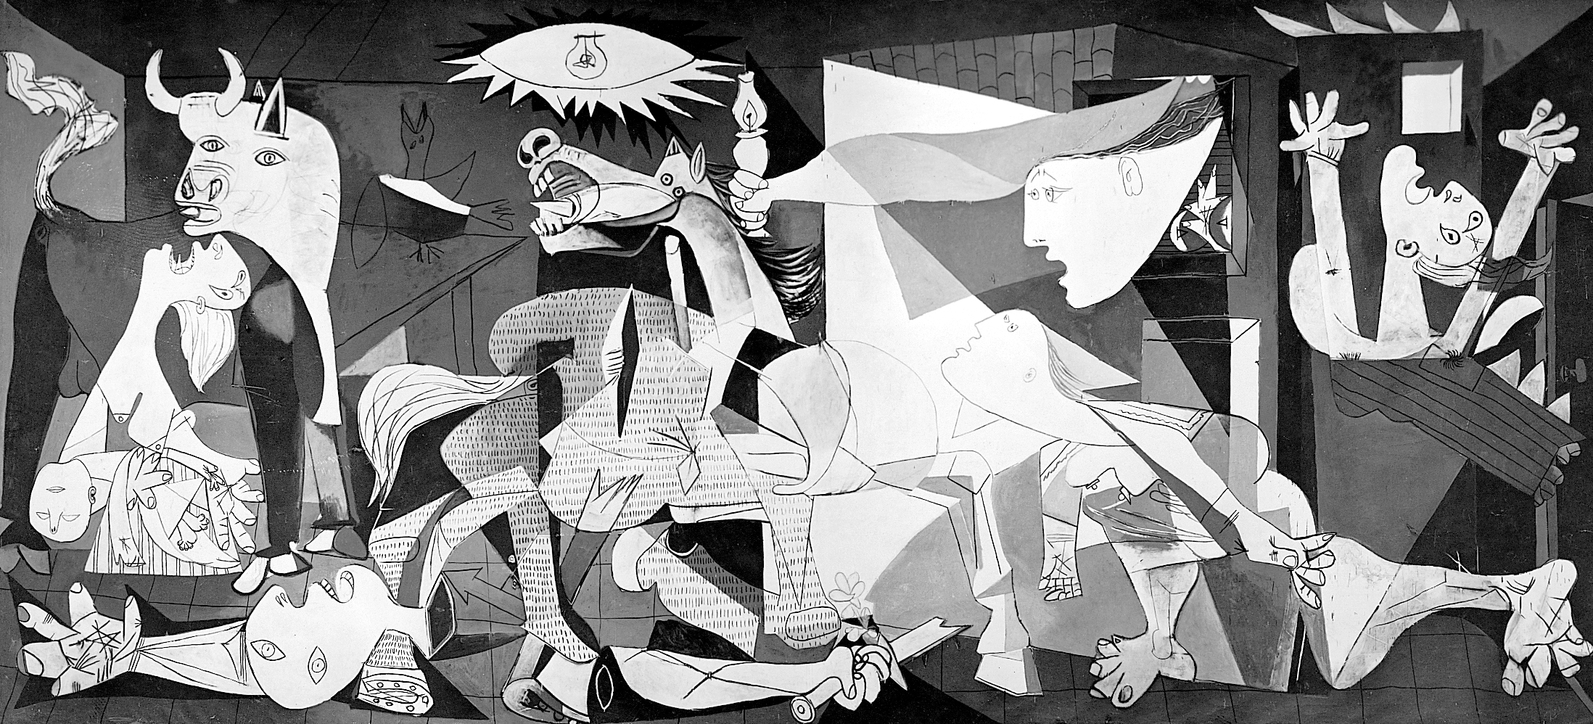 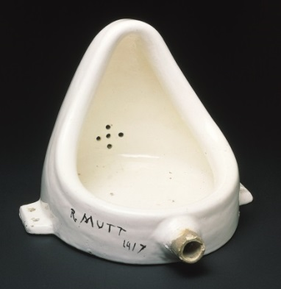 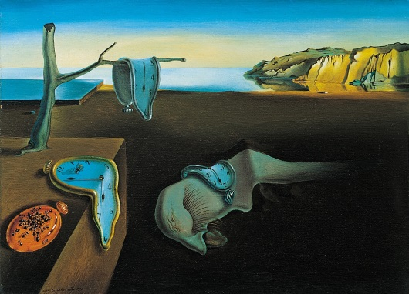

[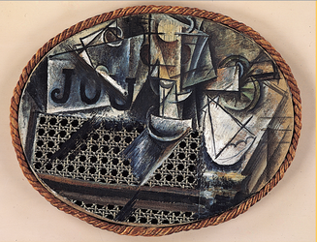](http://www.mchsapah.com/uploads/1/0/0/8/10083965/5304175_orig.png) 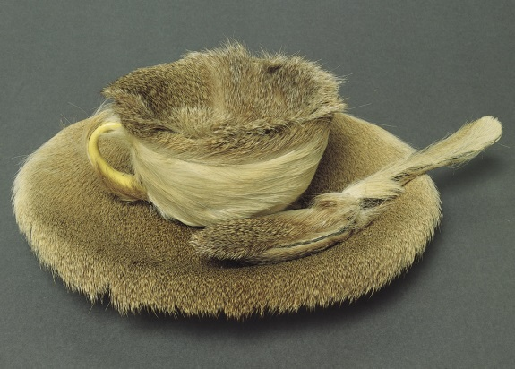 [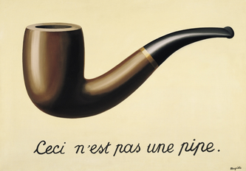](http://www.mchsapah.com/uploads/1/0/0/8/10083965/8512034_orig.png)

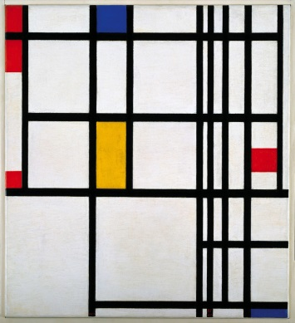 [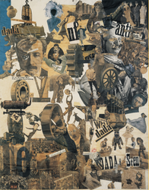](http://www.mchsapah.com/uploads/1/0/0/8/10083965/8063251_orig.png) [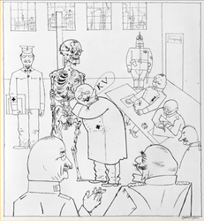](http://www.mchsapah.com/uploads/1/0/0/8/10083965/8502260_orig.png) [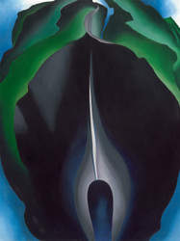](http://www.mchsapah.com/uploads/1/0/0/8/10083965/2990404_orig.jpg)

[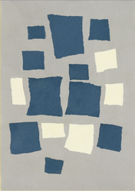](http://www.mchsapah.com/uploads/1/0/0/8/10083965/6218227_orig.png) 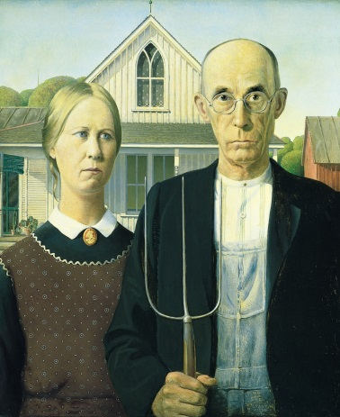 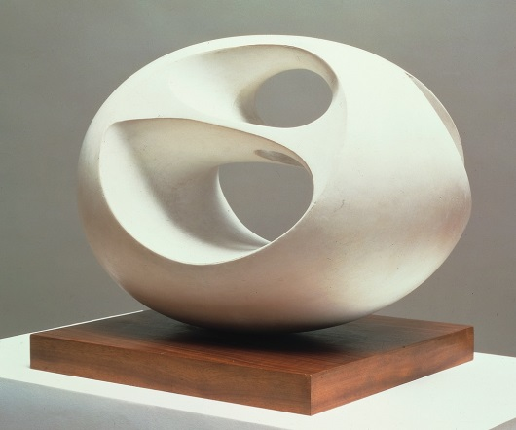

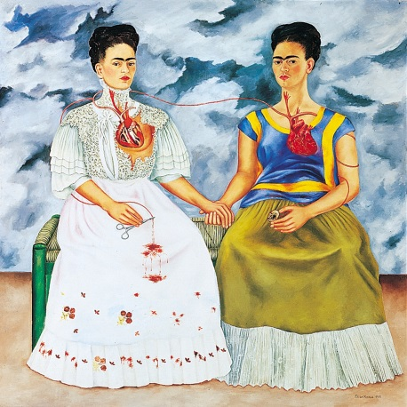 [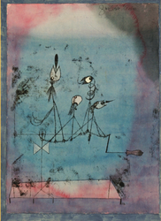](http://www.mchsapah.com/uploads/1/0/0/8/10083965/502242_orig.png) [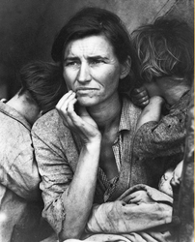](http://www.mchsapah.com/uploads/1/0/0/8/10083965/1566756_orig.png)

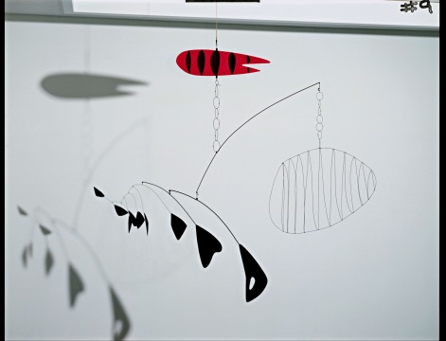 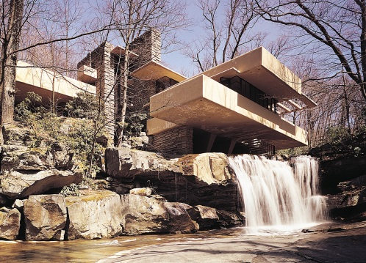 [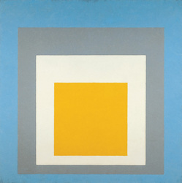](http://www.mchsapah.com/uploads/1/0/0/8/10083965/2695231_orig.jpg)