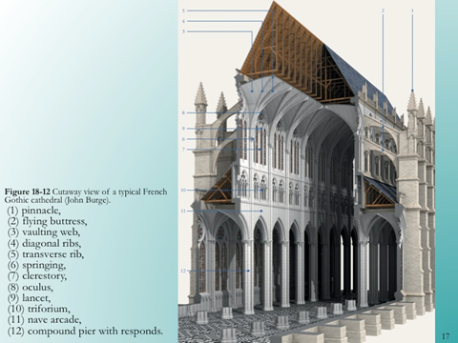

**Name _____________________**

**Label each part of this**

**typical French Gothic Church.**