Formalism and S tyle 25

Adams, The Methodologies of Art, Westview Press; Second Edition, (December 8, 2009) ys J-5"- 35'

S tyle
The aesthetic differences between works of art, insofar as they are determined by the selection and composition of formal elements, have been ordered into categories of style. Writing in the 1950s, the American art historian Meyer Schapiro defined style as "constant form-and sometimes the constant elements, qualities, and expres­ sion-in the art of an individual or a group."6 But the earliest refer­ ence to art history as a history of style occurs in the writings of the eighteenth-century German intellectual Johann Winckelmann (1719-68). His interest in Greek and Roman antiquity, fu.eled by his attraction to Greek sculpture and the contemporary excitement · aroused by the excavations at Herculaneum and Pompeii in south­ ern Italy, led to his publication of The History of Ancient Art in 1764.
For Winckelmann, in contrast to Kant and Fry, art was tied to history, and changed as the cultures that produced it changed. Inhis view, the highest achievement in the arts came about in fifth- and fourth-century B.C. Greece. Winckelmann' s compatriot of the later eighteenth and early nineteenth century, the philosopher Georg W.
F. Hegel (1770-1831), also connected stylistic change with cultural developments. He divided the history of art into three stages: the Symbolic, by which he meant ancient Egypt; the Classical, embod­ ied by Greek sculpture of the fourth century B.C.; and the Romantic, or post-Classical and primarily Christian. Hegel believed that art is a meaningful expression of those who produce it, and thus can be read as an artifact, or historical record of a culture. Like Winckelmann, Hegel saw in stylistic changes over time a kind of predetermined evolution that could be identified and described.
The late-nineteenth- and early-twentieth-century Swiss author of Principles of Art History, Heinrich Wolfflin, addressed the question of artistic development as exemplified by the shift from the High Renaissance, which he termed "Classic" because of its affinities with the Greek Classical style, to the Baroque style of the seven­ teenth century. His analysis of these two styles is a good illustration

of Schapiro's "constant form . . . in the art of an individual or a group." Wolfflin identified five pairs of stylistic concepts, which he applied to the formal organization of Renaissance and Baroque art, respectively. These are linear and painterly, plane and recession, closed and openform, multiplicity and unity, and absolute and relative clarity. If we take three pairs of works-two paintings, two sculptures, and two buildings-and compare the Renaissance example to the Baroque example, we will see that Wolfflin's categories are quite convincing. For example, Andrea Mantegna's Dead Christ [10] con­ forms to Wolfflin's notion of Classic design. It is linear in the sense that the edges of the forms and their spatial directions are clearly observable. The lines defining the sides of the platform supporting Christ's body guide the eye to a notional, but identifiable, point above the picture. This so-called vanishing point requires that the artist construct the space as if it were a rectangular box. Two sides of the box are parallel to the picture plane, which is the physical sur-

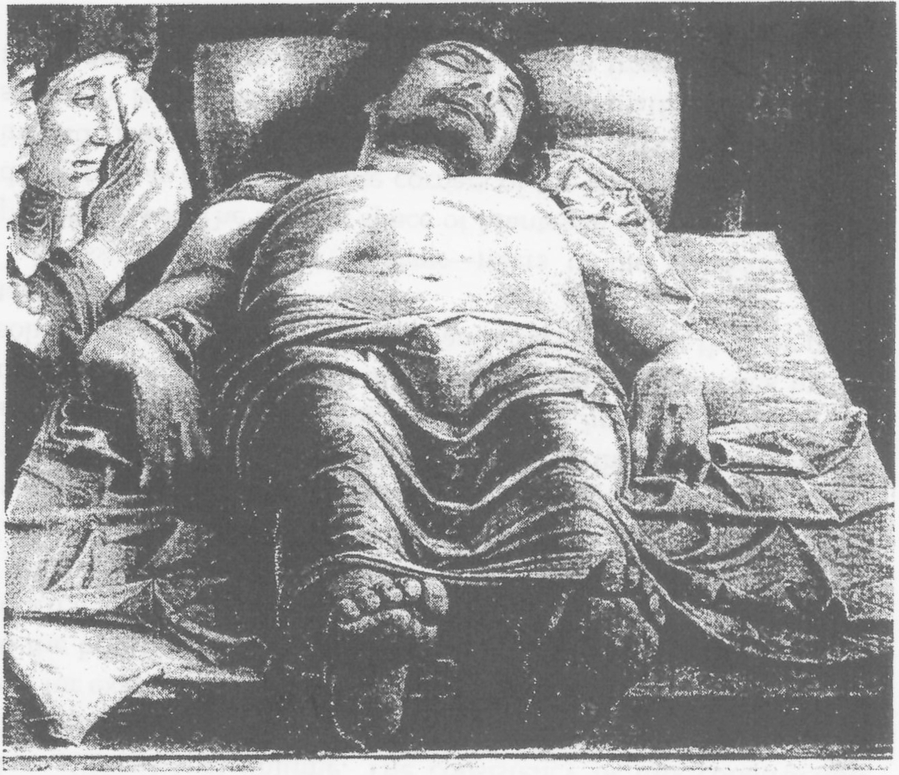
- Andrea Mantegna, Dead Christ, c. 1500, Pinacoteca di Brera, Milan.

26 T H E M E T H ODO L OG I ES OF A RT

face of the work (here the top and bottom horizontals of the plat­ form), and two are perpendicular to it (the sides). The platform itself fits into the constructed space of the painting and defines it.
By plane, Wolfflin refers fo the Renaissance painters' practice of arranging a spatial sequence identifiably parallel to the picture plane. Thus, in the Dead Christ, we can say that Christ's feet are in the foreground and that our eye is carried toward his head by a sequence of planes that includes first his legs and then his torso. In order to create the illusion that Christ does indeed lie in this relation to the picture plane, Mantegna has foreshortened his body, or paint­ ed it in perspective, as Leonardo foreshortened the right forearm of the old man in Figure 6.
We are fairly certain that the women in Mantegna's picture stand one behind the other on the floor of the room, and that the floor is parallel to the ceiling and to the platform. We can conclude that the women, and the ointment jar on the right, are upright and occupy vertical planes, whereas Christ lies in a horizontal plane. All the fig­ ures and objects, in fact, appear set within the boxlike space that seems to lie behind the picture plane. It is this conviction of identi­ fiable, and finite, space that Wolfflin refers to as closed form. Even though the vanishing point of t!iis particular image is outside the picture, its very existence gives the viewer a sense of being in con­ trol of the space. Closed form seems to be self-contained, rationally bounded, ordered, and relatively symmetrical.
InWolfflin's characterization of Classic art, each detail strikes the viewer as an independent element, even though it is also part of a larger formal arrangement. He refers to this phenomenon as multi­ plicity. Thus, for example, Christ's rib cage is composed of a distinct bone structure, musculature, and flesh, but the viewer experiences both the parts of the anatomy and the whole to which they belong. The qualities of line, plane, closed form, and multiplicity con­ tribute to Wolfflin's last category of Classic art-namely, absolute clarity. Here Wolfflin addresses the nature of light and color, which, he says, "have their own life."7 Light, in a Renaissance painting, typically enters the picture's space from one identifiable direction, independently of natural light. Inthe Dead Christ, light hits the solid forms not from an observed window but from the right. The grad­ ual shading of each form toward the lef t convinces the viewer of its
Formalism and S tyle 27

three-dimensional volume. The consistency of this construction clarifies the masses as well as the edges of form. In Christ's drap­ ery, for example, we think we know its exact placement in relation to the body and we have the sense that we could reach out and touch it.
Applying Wolfflin's formal categories to Rembrandt's Anatomy
Lesson of Dr. Nicolaes Tulp of 1632 [11], we can see how they are expressed in the seventeenth-century Baroque style. The term painterl y refers to the sense of the paint itself, the loose brushwork, and slight blurring of edges. In the Dead Christ, by contrast, the medium is subordinated to the image so that we are struck by the solid, sculptural quality of figures and drapery, rather than by paint texture.
Recession- in contrast to plane- refers to the construction of
painted space. The boxlike space of Mantegna's painting has been disrupted, as if two opposite corners of the box had been pushed inward. The resulting diagonals characterize Baroque spatial con­ struction. In Rembrandt's Anatomy Lesson, the platform supporting the cadaver recedes in a diagonal direction from its foreground

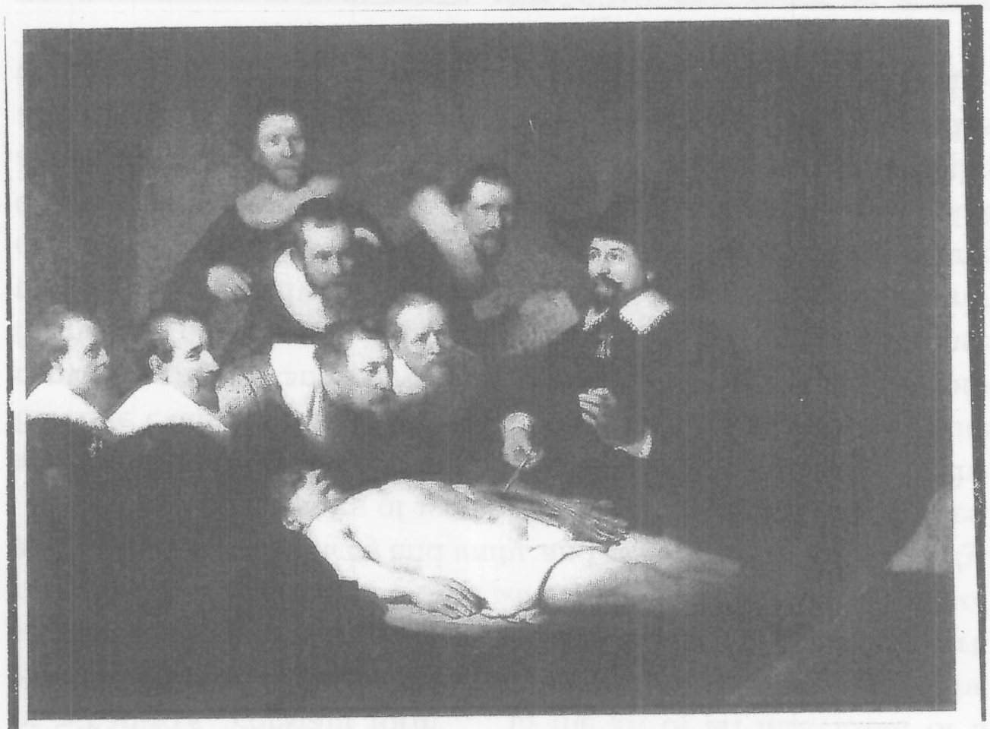
- Rembrandt, The Anatomy Lesson of Dr. Nicolaes Tulp, 1632, Mauritshuis, The Hague.

28 T H E M ET HODO L OG I ES OF A RT
,.,,
location at the lower right, back into space at the left. The obsrver is thus drawn into the pichire plane by the receding diagonal.
The placement of Rembrandt's figures, unlike Mantegna's, does not conform to an alignment of horizontal spatial planes parallel to the picture plane. Instead, the doctors observing the dissection occupy an ambiguous space. It is not clear, for example, where the man holding the letter stands in relation to those concentrating on Dr. Tulp's procedure. Because of such ambiguity, it would not be possible, as it is in the Dead Christ, to reconstruct the floor plan of Rembrandt's painted room.
Open space- in contrast to closed space- is like an open mind; it allows for a sense of flexibility. Open space permits the easy access and flow of figures and objects, just as various ideas and points of view are considered by one with an open mind. Likewise, the diago­ nal planes of Baroque construction create asymmetry, which opens the form. Despite the dark background of the Rembrandt, its space is not bounded except by the frame itself. Inside the picture, figures, objects, and architecture are more fluid than their Renaissance counterparts. The impression of formal movement in the Rembrandt is enhanced by individual diagonals such as the two sides of the book, the hands and hat of Dr. Tulp, the doctors leaning forward, and the cadaver.
The unity, rather than the multiplicity, of the Anatomy Lesson, according to Wolfflin's system, resides in the nature and action of the figures and the system of lighting. The doctors are gathered around the dissecting table and thus convey a group character. The light, which does not enter the picture plane from a single direction, is distributed on the faces, collars, and hands, on the book, and most broadly across the cadaver. The accents of light are just that; they highlight form-like spotlights on a stage-whereas in the Dead Christ, the light defines form. In Wolfflin's conception of Classic con­ struction, therefore, the light is subordinate to the form, while in Baroque style the domination of light has a unifying effect.
The relative clarity of the Rembrandt contrasts with the _ absolute clarity of the Mantegna. Since the light in the Anatomy Lesson does not define form, certain areas of the picture plane are highlighted, leaving other areas in darkness. The edges of the figures, the cover of the book, and the outline of the dissecting table are not as clearly identifiable as the edges in the Renaissance picture. Likewise, the painterly quality of
Formalis m a nd S tyle 29

the brushstrokes decreases the clarity of edge, and the ambiguous location of some figures blurs their spatial relationship to one another. The two marble Davids by Michelangelo and Bernini will serve to illustrate Wolfflin's paired categories of style as they apply to sculp­ ture. Michelangelo's David [12] stands in a vertical plane on a hori­ zontal base, and its outline conforms to the boxlike space of Classic design. The figure's limits are clearly visible to the observer, and we have the impression that we have a full view of the front of the body. Bernini's David [13], on the other hand, turns vigorously, cre­ ating a sweeping diagonal of movement and an asymmetrical form. As a result, we cannot have a full front view of the figure and there­
fore see it less comprehensively than Michelangelo's David .
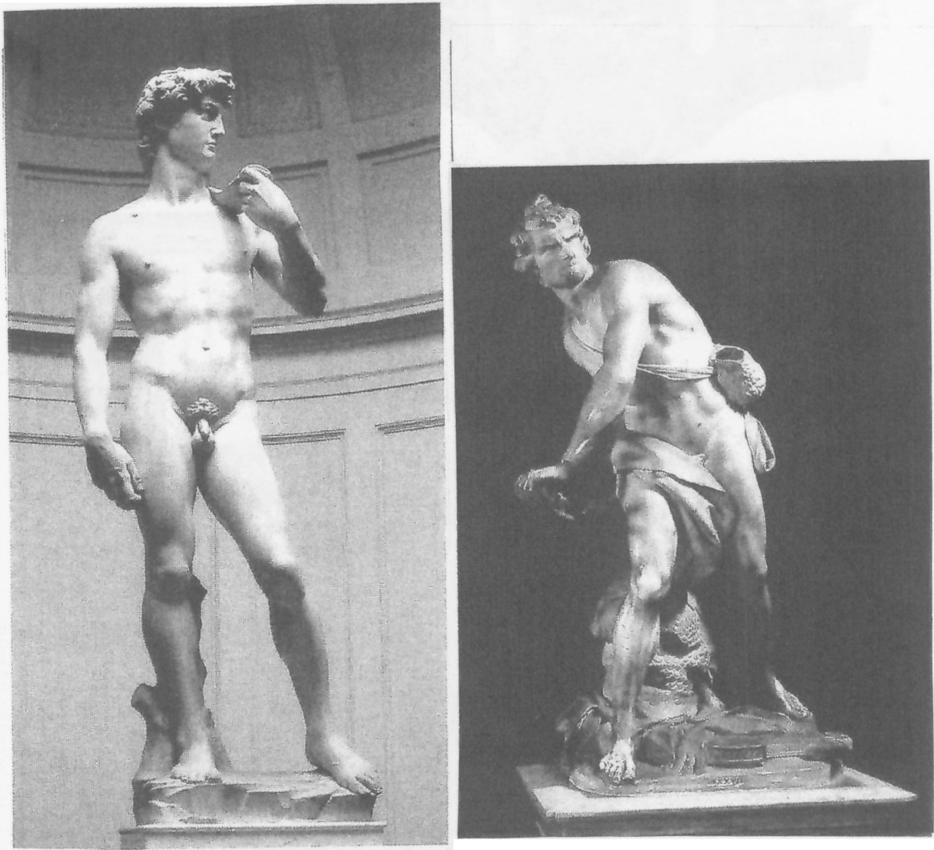The diagonal plane of the Bernini, like that of Rembrandt's dis­ secting table, opens the space and creates motion through that space. It also subsumes the parts to the whole, whereas in Michelangelo' s
12. Michelangelo, David. 1501-4,
Accademia, Florence.
13. Gian Lorenzo Bernini, David, 1623,
Galleria Borghese, Rome.

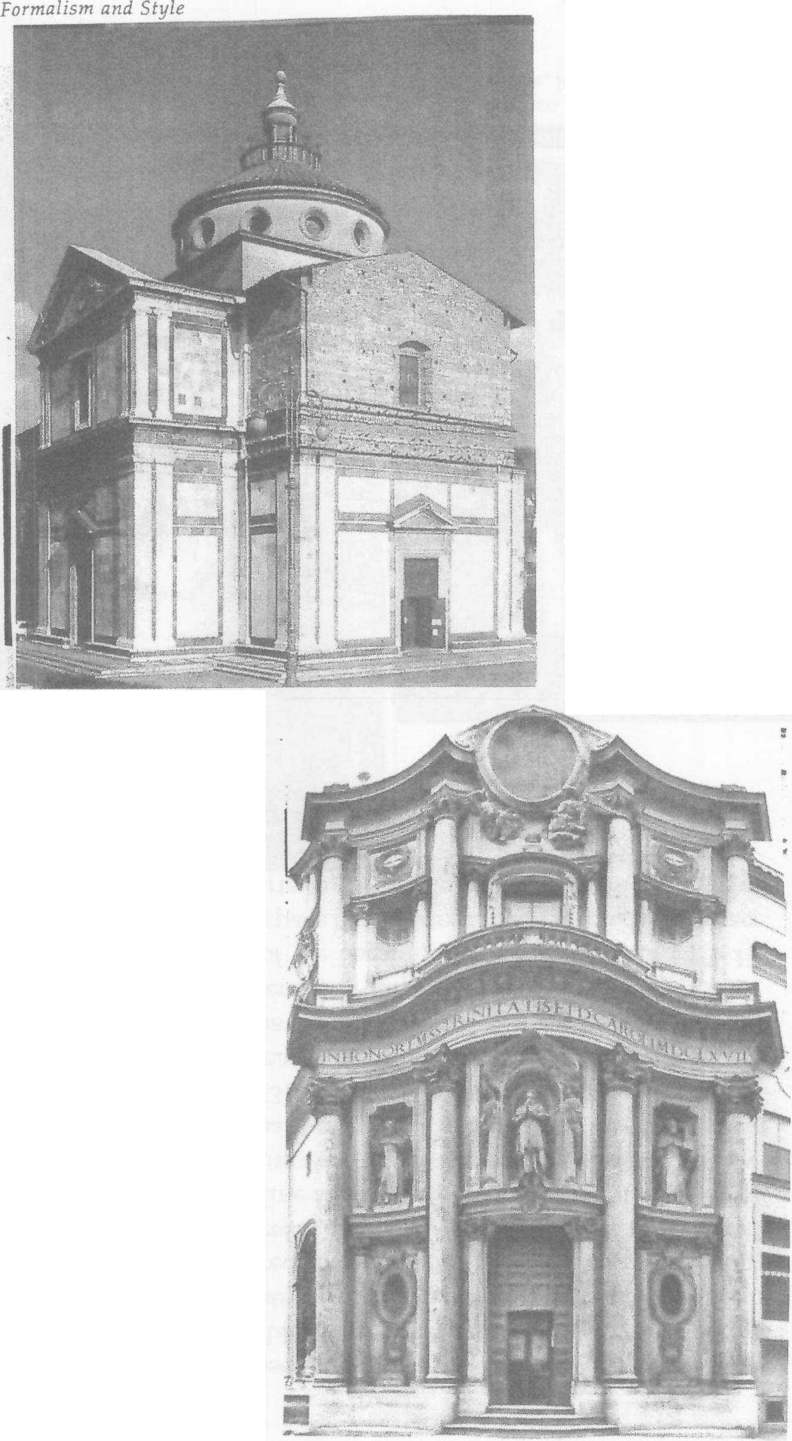
31
14. Giuliano da Sangallo,
Santa Maria delle Carceri, 1485--92 Prato.
15. Francesco Borromini,
San Carlo alle Quattro
Fontane, 1665-67, Rome.

30 TH E M ET HO DO L OG I ES O F A RT
,,

figure individual parts, such as the rippling muscles, are experi­ enced more distinctly by the.observer. The greater variety of open spaces around the exterior of Bernini's David and the details of drapery and the pouch add to the formal movement of the statue.
Two examples of church architecture that exemplify the differ­ ence between Classic High Renaissance style and Baroque are Giuliano da Sangallo's Santa Maria delle Carceri (1485-91) in Prato [14] and Francesco Borromini's San Carlo alle Quattro Fontane (1665---67) in Rome [15]. Since the plan of Santa Maria delle Carceri is based on the shape of a Greek cross, the building is symmetrical and the four sides are virtually identical. Rising over the center is a drum with twelve round windows and a ribbed dome surmounted by a lantern. The correspondence between inside and outside (shown here) contributes to the clarity of the building structure. Shapes include the basic square, rectangle, circle, and triangle, arranged in a regular rhythm. The horizontals extending from the comers of the pediments are repeated in, and aligned with, those in the comer angles of the building. Also repeated is the relationship of the large and small rectangles on the surface. Each part is thus very much integrated with the design of the whole.
The planes of Santa Maria delle Carceri are vertical and horizontal, like those of Renaissance painting and sculpture, varied only by the sloping pediments and the circles of the dome. They lead our eye inward in a regular progression so that we feel in control of the space. As a result, the space itself strikes us as limited, enclosed, and ordered.
The plan of the Baroque church of San Carlo alle Quattro Fontane is elliptical, and the alternation of convex and concave elements in the facade is enlivened with detail that alters the sense of quiet order. Massive disengaged columns and projecting entablatures cast large shadows that multiply the contrasts of light and dark and obscure parts of the facade. Further increasing motion, and opening up spaces, are the decorative details carved in relief at various points in the surface. The elaboration of decorative elements, sharp contrasts, and the curved walls and entablatures affect the planar impression of the church facade. The sense of shifting elements, whether structural or in the variations of light and dark, tends to merge the forms, much as the painterly quality of Baroque pictures blurs edges and outlines. Although there are inevitably many exceptions to categories such
'i;
t

32 ..,, THE MET HODOLOG I ES O F A RT

as Wolfflin's, his system confirms the formal consistency of style. It also helps to distinguish Renaissance (or Classic) from Baroque style. In constructing this system, Wolfflin has essentially shown that it is possible to identify broad categories of style and to situate them within historical and cultural frameworks.

Despite Wolfflin's emphasis on the formal qualities of style and their aesthetic impact on the viewer, he links style to history and culture, and thus departs from the purely formalist approach of Kant and Fry. According to Fry, art has its own history and its own dynamic, which can be understood independently of context. Fry illustrates his view of artistic independence from social and political history by pointing out that a revolution in one cultural area does not necessar­ ily coincide with a revolution in another. For example, he noted that the art of the Roman Empire was largely unaffected by the Christian revolution taking place in its midst.8 The seventeenth-century artis­ tic transition from the Renaissance to Baroque was not, in Fry's view, reflected in social or political change, although the Renaissance rev­ olution in art did correspond to the social, political, and philosophi­ cal development of humanism.
Historically closer to Fry's own time were the Impressionists, who, from the middle of the nineteenth century, began to reject the traditional view of mimesis and the notion that the purpose of art was to represent nature figuratively. According to Fry, a new era began with Cezanne, whose revolutionary approach to the picture plane appealed primarily to the viewer 's aesthetic sensibility. As for the correspondence of Cezanne's innovations with historical developments, Fry was content to wait and see.
The other major English formalist critic of the early twentieth century, Clive Bell, preceded Roger Fry. But Bell was neither as complex nor as influential as Fry.9 He, too, recognized a new and revolutionary development in the paintings of Cezanne. Writing about 1911-12, Bell identified Cezanne as the perfect artist10 because he painted primarily to achieve "significant form." "Thou shalt cre­ ate form" is Bell's first commandment of art.11 The importance of significant form, which succeeds in evoking aesthetic emotions based on one's subjective experience of a work of art, was para­ mount for Bell. The aesthetic response, as for Fry, depended on the
Formalism and Style 33

artist's arrangement of formal elements-lines and colors, spaces and shapes, lights and darks-rather than on subject matter.
Bell likened art to religion and endowed it with moral value. He believed in the religious power of art to lead people "from circum­ stance to ecstasy,"12 outside of time and place, regardless of histori­ cal context. Even more than being independent of time and place, art, according to Bell, carries an inner truth, a "latent reality" that enriches life. For not only does art owe nothing to life, in Bell's view, but life probably owes a great deal to art. And, to reinforce the power of art over life, he recommended reading history in the light of aesthetics rather than reading aesthetics in the light of history.
For Bell, therefore, aesthetic form, rather than context or content, was primary. This was true of his view of the history of the individ­ ual as well as of cultural history. He believed that children are born with a natural sense of form,13 which makes everyone a bit of an artist. "Do not tamper," he wrote, "with that direct emotional reac­ tion to things which is the genius of children."14 He also thought that society should leave artists alone and provide them with the free­ dom to work. For the institutions of society, including the art schools, have little to contribute to the arts, but the arts might redeem society.
Bell regarded the history of art as a series of ups and downs with­ in an ongoing stream, and he was quite clear about his own aes­ thetic response to form. He believed that Europe had produced more good art from A.O. 500 to 900 than from 1450 to 1850, and that Gothic art was the beginning of a decline in quality. He described Gothic architecture as "juggling in stone and glass"15 and the cathe­ dral as an impressive, melodramatic tour deforce that was neverthe­ less not aesthetically thrilling. He preferred the "significant forms" of the Byzantine style to the lifelike character of Giotto's work, which he saw as a high point before the decline.
Bell's objection to the Renaissance, which he called a "new dis­ ease" of art-as-imitation, could only have emerged from a formalist perspective. He felt that Renaissance artists sacrificed spiritual qual­ ity to science. He called Chardin the only great painter of the eigh­ teenth century and believed that by 1850 art was dead. Then, he asserted, the Impressionists revived art and taught viewers to seek the significance of a work within itself and not in the outside world.

34 ,., T H E M E THODOLOG I ES OF A RT

And finally, Cezanne, unlike the artistic dead end of Raphael and the High Renaissance, opened up new formal possibilities.
Bell's aesthetic preferences are consistent with his formalism. He generally disliked what was most naturalistic, such as Renaissance and early-nineteenth-century art. The spiritual art of the early Middle Ages and the Byzantine era, the "moral" tone of Chardin's work ethic, and the Impressionist emphasis on the expressive qual­ ities of the medium appealed to him. His aesthetic conviction that Cezanne introduced a new kind of "significant form" has been borne out by developments of the past hundred years.
Notions of stylistic trends, cycles, ups and downs, and so forth have been around for centuries. Whatever one's view of the histor­ ical dynamics of style, one might or might not relate it to a cultural
,-;:-· Formalism and Style 35
spective (as in the Renaissance) or receding diagonal planes (as in Baroque), the visual elements of modem painting seemed to occur where, in fact, they do occur-directly on the picture plane. "Pictorial space," Greenberg said, "has lost its 'inside' and become all 'outside."'16 He noted that abstraction, which he considered the best art of his time, had evolved when artists turned from imitat­ ing nature to the forms and processes of art.17 Like Fry, Greenberg assigned value to works of art insofar as they were experienced deeply and significantly. For both critics, the depth and signifi­ cance of the subjective experience were a response to the qualities of form, and not to the content.
NOTES

context. By and large, the formalists do not, although they may have strong opinions about a particular style. They also recognize the existence of styles, but their interest lies in the history and the aes­ thetic effect of style and not in the history of cultural ideas, politics, economics, literature, or science. Nor are they interested in the biographies of the artists or the relevance of those biographies to the works of art. They take art on its own formal terms and experience it according to their personal aesthetic response.

The beginnings of the formalist approach coincide with the develop­ ment of Impressionism and Post-Impressionism . Fry was an early supporter of Post-Impressionism in England, because that style (par­ ticularly the example of Cezanne) seemed to embody his belief inthe importance of form over content. Post-Impressionism had structural qualities that Impressionism, with its dissolution of form, lacked. In the twentieth century, the popularity of formalist criticism paral­ leled, to some degree, the development of abstraction.
The formalist whose views were most clearly derived from those of Fry was the American critic Clement Greenberg. For Greenberg, who wrote from the 1930s through the 1960s, mod­ ernism consisted of the renunciation of illusionism (in the Platonic sense of mimesis) and of the conception of the picture plane as the fourth wall of a stage. The result was a flattened picture that no longer replicated our experience of three-dimensional space. Rather than drawing viewers into an imagined space through per-
- See Immanuel Kant, Critique of Judgment, trans. J. H. Bernard (New York, 1951).
2 Roger Fry, "An Essay in Aesthetics " (1909, New Quarterly), in Vision and Design (New York, 1956).
3. Ibid., p. 17.
4. Ibid., p. 27.
- Roger Fry, "The Artist's Vision" (1919, Athenaeum ), in Vision and Design, pp. 47-54.
- Meyer Schapiro, "Style," inAesthetics Today, ed. Morris Philipson (New York, 1961), p. 81. Reprinted from Anthropowgy Today, ed. A L. Kroeber (Chicago, 1953).
7. Heinrich Wolfflin, Principles of Art History, trans. M. D. Hottinger (New York, ILd), p. 16.
- Roger Fry, "Art and Life," lecture to the Fabian Society, in Vision and Design, pp. 1-15.
- Clive Bell, Art (New York, 1958).
10. Ibid., p. 135.
11. Ibid., p. 38. 12. Ibid., p. 68. 13. Ibid., p. 186. 14. Ibid.
15. Ibid., p. 102.
- Clement Greenberg, "Abstract, Representational , and So Forth" (1954), in Art and Culture (Boston, 1961), p. 136.
- For a persuasive rebuttal of Fry, Greenberg, and formalism, see Leo Steinberg, Other Criteria (New York, 1972), esp. ch. 3.

AP Art History Dialectical Entry Ms. Park
By completing this you will:
- bring your own background and experience to the reading
- construct your own meaning from the text of the article
- provide direct feedback to yourself and the class on your thoughts and understanding as you read

What to include in your entry:
- J st column: You're writing at least 3 quotes that you like, think are important, don' t understand, prove a point, or have a personal connection to..
- 2nd column: You ' re writng a response to each of the quotes that you chose in the 1 st column.

1.
2.
3.

