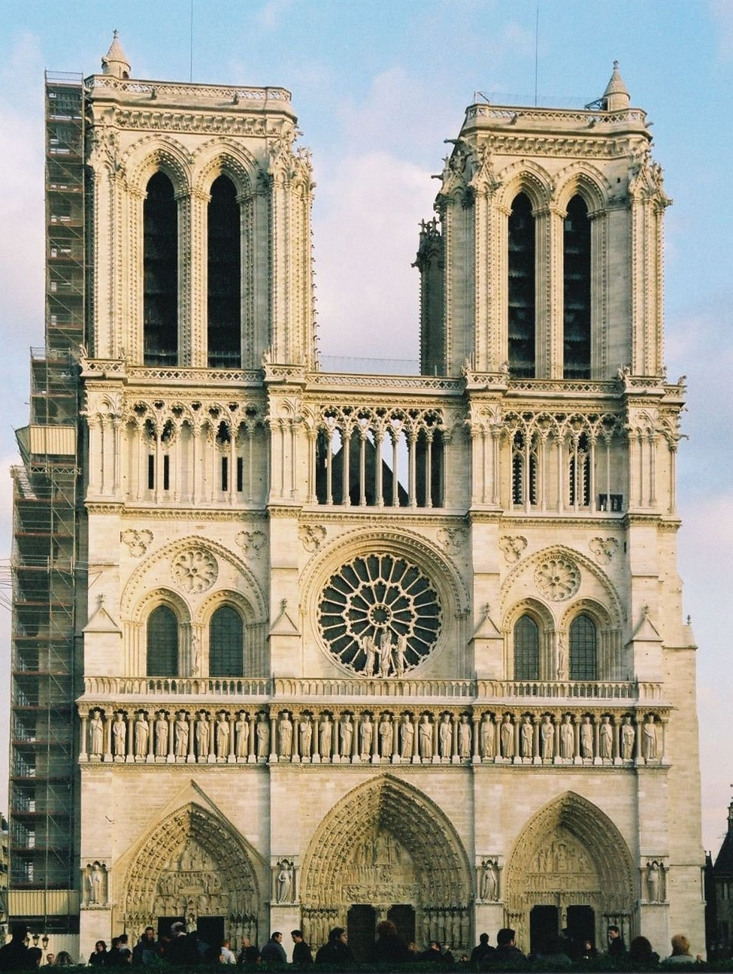

1. Label the following: Early Gothic

* Rose window
* Bell Towers
* Portal
* Gallery sculptures
* Hanging space for bells

Name___________________________________

List the following parts

of the façade:

* Portal
* Tympanum
* Voussoirs
* Trumeau
* Jambs
* Jamb sculptures
* Lintel
* Archivolts

