Early Gothic: 1140- 1194 (France)
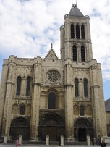 Facade of Saint Denis, Paris, France

- Characterized by round columns in the interior
- Rib vaults start at ceiling by travel down only to the top of the column capitals

High Gothic, Rayonnant Gothic: 1194-1300 (France)
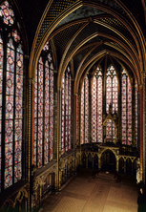 Interior of St. Chapelle, Paris, France

Rayonnant = "radiating"
- Articulated columns in the interior
- Rib vaults travel from ceiling to floor
- Larger window space, choirs, and chevets
- Dissolution of wall space with the used of stained-glass windows

Late Gothic, Flamboyant Gothic: After 1300 (France)
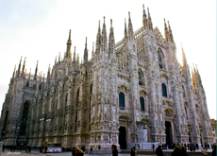 Milan Cathedral, Milan, Italy

Flamboyant = "flaming"
- Highly decorative
- A mass of pinnacles and tracery
- Ogee arches

Perpendicular Gothic: After 1350 (England)
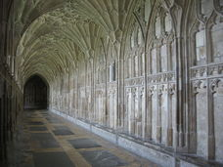 Gloucester Cathedral, England
- Constructed in a garden like setting (inspired by cloisters)
- Extremely pronounced central spires
- Smaller flying buttresses and portals
- Lower towers and wide screen like facades (full of sculpture)
- **Enormous window spaces interlaced with decorative vertical patterns of stone tracery.

