Name:________________ AP Art History: Gillis
Greek Architecture: Vocabulary

This temple is of the ______________ Order

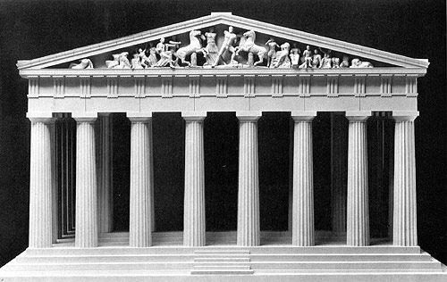

This temple is of the _______________ Order.

