Key Ideas
- Revitalization of classical ideals in literature, history, and philosophy.
- Renaissance courts influenced by humanism (Secular over the religious)
- Humanism is hugely popular and more and more people are attracted to the ideals. It fostered the belief in individual potential
- Rise in realistic, 3D paintings
- Human anatomy: increase in nude sculptures
- Architecture emphasizes light spaces that are balanced and symmetrical.
- Political and economic changes that contributed to the rise of a new class of wealthy patrons (Medici Family) who fostered art and learning on a lavish scale.

Characteristics of Architecture
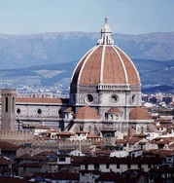Cambio, Dome of the Florence Cathedral
- Renaissance architecture depends on order, clarity, and light.
- Wide window spaces, limited stained glass, vivid wall paintings in most cases.
- Stressed mathematical perfection and geometric designs
- Ideal proportions = humanistic ideals = spatial harmony
Characteristics of Painting and Sculpture

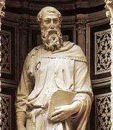
Painting: The use of linear perspective is most important (attributed to Brunelleschi)
- Painting: The use of linear perspective to intentionally fool the eye = tromp l'oeil
- Sculpture: Relief carvings, with their flat planes, were deeply incised to create a sense of depth.
- Early 15th c. religious images still dominated but by the end of the 15th c. mythological subjects and portraiture proliferated
- Interest in humanism and the rebirth of Greco-Roman classics also spurred an interest in authentic Greek and Roman sculptures.
- Greater willingness to paint and sculpt the nude, particularly the male nude.
- Usually shows the intense physical interaction of form.

