**Flash Card Images – Early medieval Art - Europe**

[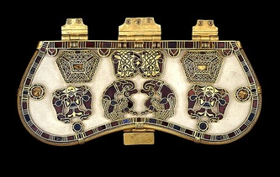](http://www.mchsapah.com/uploads/1/0/0/8/10083965/8406345_orig.jpg) [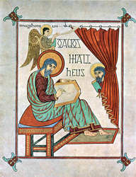](http://www.mchsapah.com/uploads/1/0/0/8/10083965/2141884_orig.jpg) [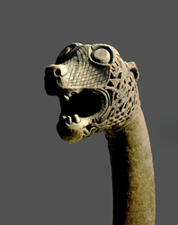](http://www.mchsapah.com/uploads/1/0/0/8/10083965/5641701_orig.jpg)

[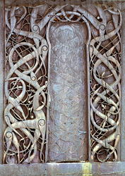](http://www.mchsapah.com/uploads/1/0/0/8/10083965/2442780_orig.jpg) [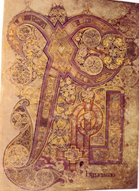](http://www.mchsapah.com/uploads/1/0/0/8/10083965/5280650_orig.jpg) [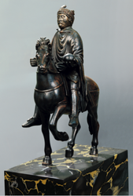](http://www.mchsapah.com/uploads/1/0/0/8/10083965/4557990_orig.png)

[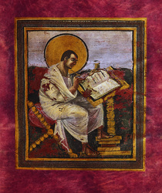](http://www.mchsapah.com/uploads/1/0/0/8/10083965/654402_orig.jpg) [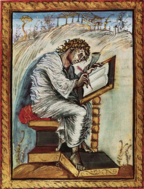](http://www.mchsapah.com/uploads/1/0/0/8/10083965/5965694_orig.jpg) [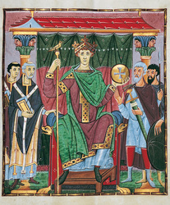](http://www.mchsapah.com/uploads/1/0/0/8/10083965/2365396_orig.jpg)

[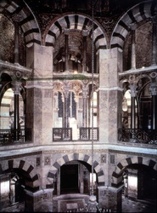](http://www.mchsapah.com/uploads/1/0/0/8/10083965/3279703_orig.jpg) [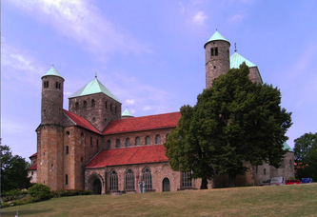](http://www.mchsapah.com/uploads/1/0/0/8/10083965/2692729_orig.png)

[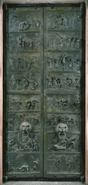](http://www.mchsapah.com/uploads/1/0/0/8/10083965/1185216_orig.png) [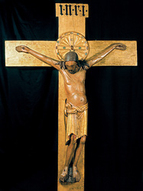](http://www.mchsapah.com/uploads/1/0/0/8/10083965/8904563_orig.jpg) [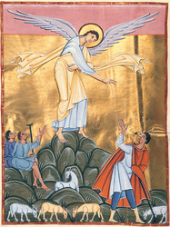](http://www.mchsapah.com/uploads/1/0/0/8/10083965/7152121_orig.jpg)