Flanders: Rubens' - The Elevation of the Cross
The two most important artists of the Baroque era in Northern Europe (what we knew as Flanders in the 15th century)—Rubens and Rembrandt—worked under enormously different circumstances, even though they lived only a few hundred miles apart, because Flanders became divided along religious lines in the 16th century. The area which is today Belgium remained Catholic (where Rubens lived), while the area which is today the Netherlands, or Holland (where Rembrandt lived) broke away from Catholic Spain (which had controlled it) and established an independent Republic that was predominantly Calvinist (a form of Protestantism).
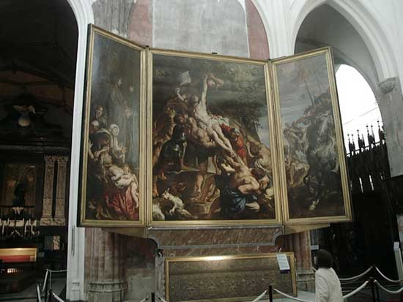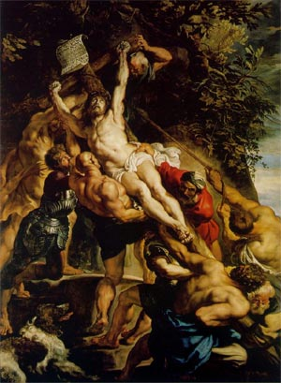
Peter Paul Rubens, The Elevation of the Cross, oil on canvas, 1610-1611 (Cathedral of Our Lady, Antwerp)
Rubens was an enormously successful artist in the first half of the 1600s. His paintings were sought after by important patrons all over Europe. A shrewd businessman, Rubens was of course, also a devout Catholic. He is also a perfect example of the changed status of the artist: his friends and confidants were scholars, aristocrats, and even the Royal Families of Europe (Rubens was so trustworthy and clever that he served as a diplomat).
Rubens spent several years in Italy early in his career studying Italian Renaissance art, as well as the art of classical antiquity. He combined this with the influence of Caravaggio, the Venetian artists of the Renaissance, the Baroque, and the tradition of his native Flanders (think Campin and Van Eyck). Rubens was so successful that he set up a large studio in his native Antwerp (which you can still visit). There, he churned out large numbers of paintings for his royal and wealthy clients, and charged for the paintings according to how much he had personally painted. He was always responsible for the idea of a painting, but if his assistants executed most of it, the work was less expensive. In his studio Rubens had assistants working for him who specialized in different things, so they could all work on different parts of a single painting. Although Rubens perfected this system, we know that it was common practice for the "Master" artist to have the idea and do much of the actual painting, but to have apprentices and assistants work on it, too.

